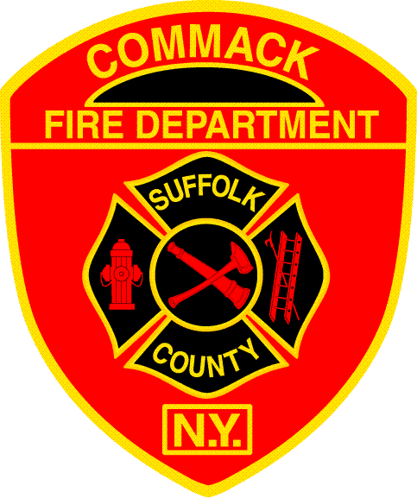
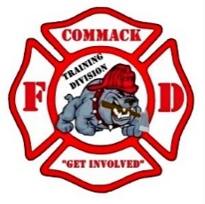
Commack Fire Department
Training Division
__________________________________________________________________________________

Practical Skills Checklist – Annual E.E.S. Requalification

Name: | Badge: | Date:

Task: | Satisfactory | Unsatisfactory
Demonstrates a proper MAYDAY
Demonstrates proficiency in deployment and window bailout
Demonstrates proficiency in repacking and storing system

Comments

Evaluator: | Date:

Overall Performance | Pass | Fail

